**Matlab Image Processing Results**

**Multiplying 2 matrices**

>> A = [1 2 3 4 5;2 3 4 5 2;1 2 4 5 3;1 2 3 4 2;1 3 4 5 2]

A =

1 2 3 4 5

2 3 4 5 2

1 2 4 5 3

1 2 3 4 2

1 3 4 5 2

>> B = [0 0 0 0 1;0 0 0 1 0;0 0 1 0 0;0 1 0 0 0;1 0 0 0 0]

B =

0 0 0 0 1

0 0 0 1 0

0 0 1 0 0

0 1 0 0 0

1 0 0 0 0

>> C = A*B

C =

5 4 3 2 1

2 5 4 3 2

3 5 4 2 1

2 4 3 2 1

2 5 4 3 1

**Multiplying two matrices element wise**

>> D = A.*B

D =

0 0 0 0 5

0 0 0 5 0

0 0 4 0 0

0 2 0 0 0

1 0 0 0 0

**Loading an image and displaying it**

>> Image = imread('image.jpg');

>> imshow(Image);

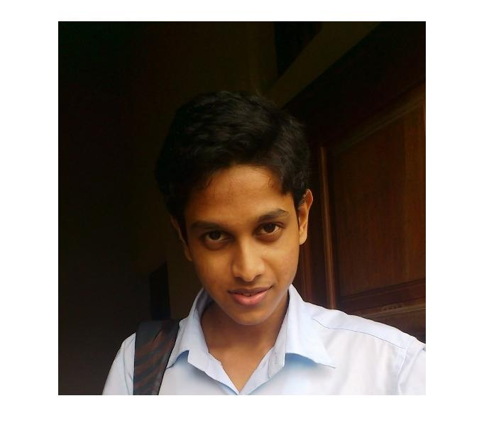

**Using size function to get the dimensions**

>> size(Image)

ans =

527 518 3

**Displaying RGB layers separately**

>> R = Image(:,:,1);

>> G = Image(:,:,2);

>> B = Image(:,:,3);

>> imread(R);

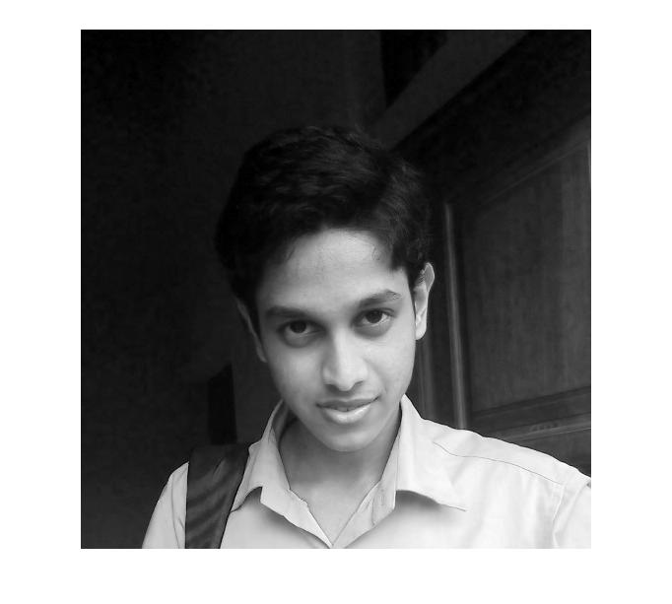

>> imshow(G);

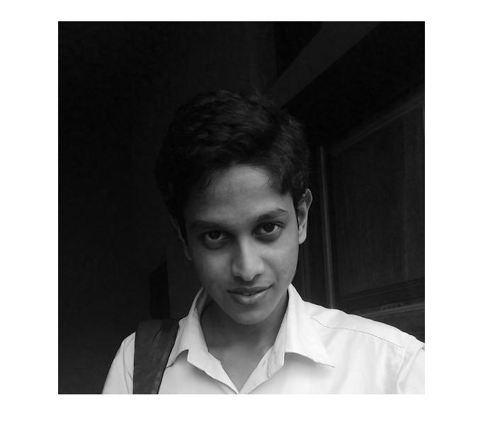

>> imshow(B);

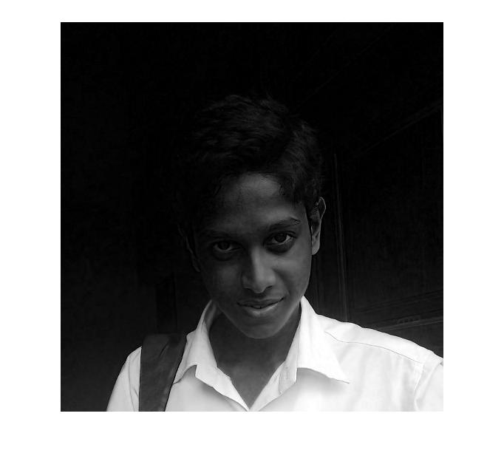

**Converting the colored image to gray scale**

>> GrayScale = (R + G + B) / 3;

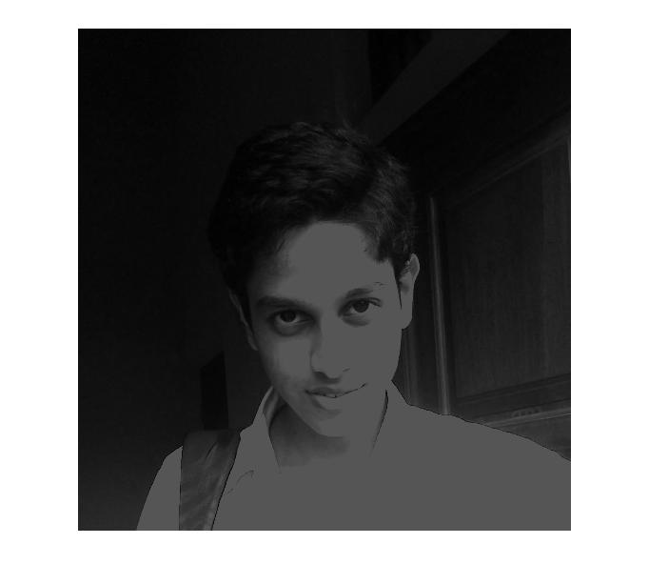>> imshow(GrayScale);

>> GrayScale2 = rgb2gray(Image);

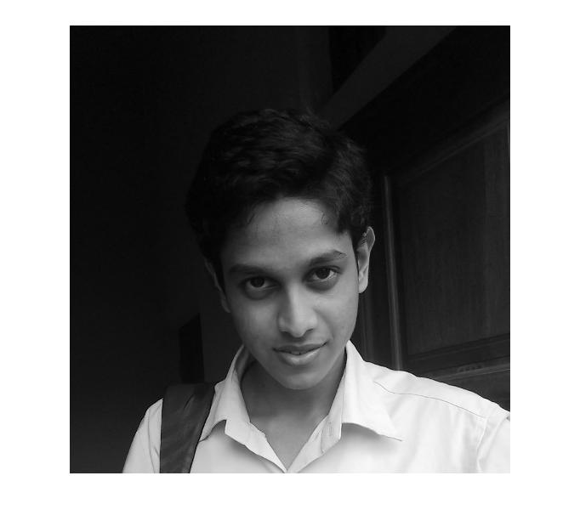>> imshow(GrayScale2);

**Image convolution using my own function**

>>edit convert

function [Output] = convert(Image,Kernel)

Output = zeros(size(Image,1),size(Image,2));

Rows = int32(size(Image,1));

Cols = int32(size(Image,2));

K_Size = int32(size(Kernel,1));

for i=(K_Size/2):(Rows -(K_Size/2) + 1),

for j=(K_Size/2):(Cols -(K_Size/2) + 1),

Tot=0;

a = i+1-(K_Size/2);

b = i-1+(K_Size/2);

c = j+1-(K_Size/2);

d = j-1+(K_Size/2);

Reduced_Matrix = Image(a:b,c:d);

Reduced_Matrix = Reduced_Matrix.*Kernel;

Tot = sum(Reduced_Matrix(:));

Output(i,j) = Tot;

end

end

>> Image = im2double(Image);

>> R = Image(:,:,1);

>> G = Image(:,:,2);

>> B = Image(:,:,3);

>> Kernel = [1 1 1;1 1 1;1 1 1]

Kernel =

1 1 1

1 1 1

1 1 1

>> Converted_R = convert(R,Kernel);

>> imshow(Converted_R);

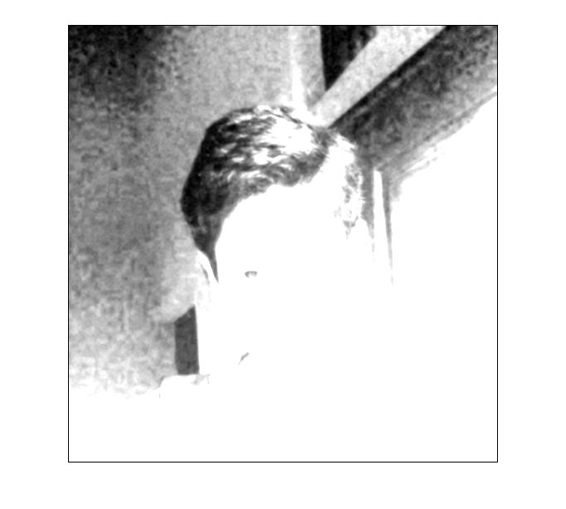

>> Converted_G = convert(G,Kernel);

>> imshow(Converted_G);

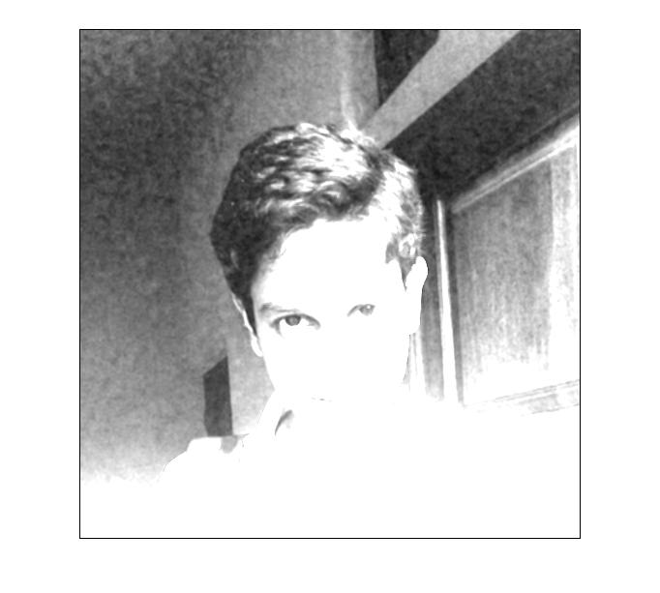

>> Converted_B = convert(B,Kernel);

>> imshow(Converted_B);

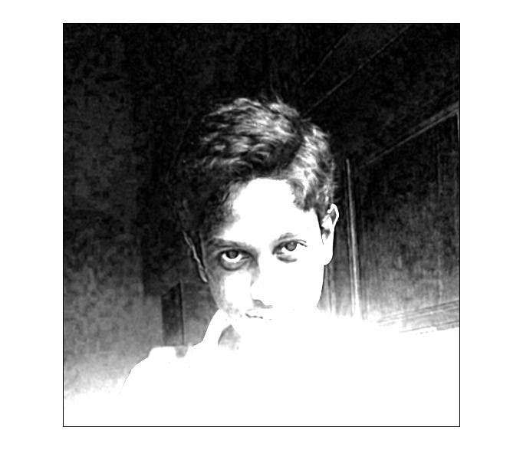

>> Converted_Image = cat(3,Converted_R,Converted_G,Converted_B);

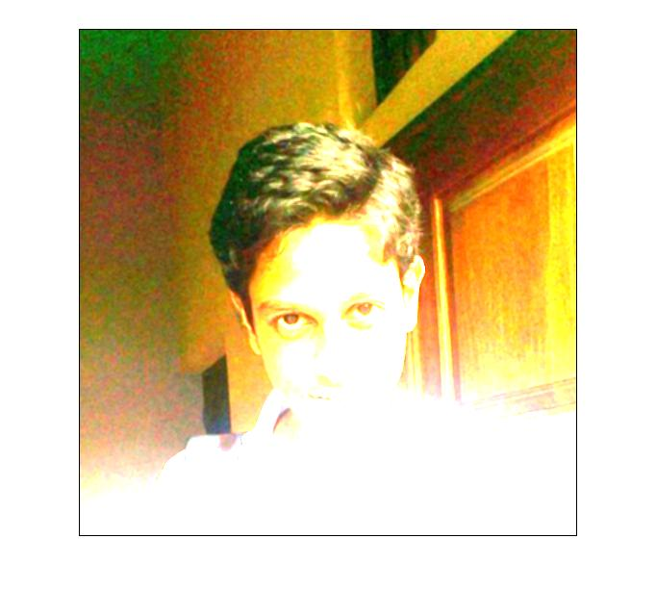>> imshow(Converted_Image);

**Using ‘conv2’ function**

>> Converted_R2 = conv2(R,Kernel);

>> Converted_G2 = conv2(G,Kernel);

>> Converted_B2 = conv2(B,Kernel);

>> Converted_Image2 = cat(3,Converted_R2,Converted_G2,Converted_B2);

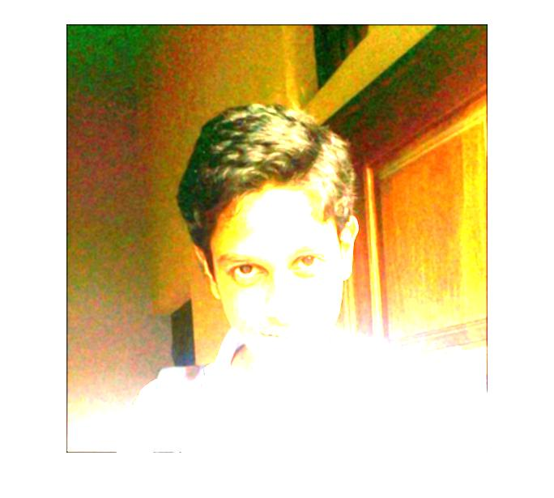>> imshow(Converted_Image2);

**Image Convolutions**

**1. Image blurring**

**a. Simple Box Blur**

>> Kernel = [1/9 1/9 1/9;1/9 1/9 1/9;1/9 1/9 1/9]

Kernel =

0.1111 0.1111 0.1111

0.1111 0.1111 0.1111

0.1111 0.1111 0.1111

>> Converted_R = convert(R,Kernel);

>> Converted_G = convert(G,Kernel);

>> Converted_B = convert(B,Kernel);

>> Converted_Image = cat(3,Converted_R,Converted_G,Converted_B);

>> imshow(Converted_Image);

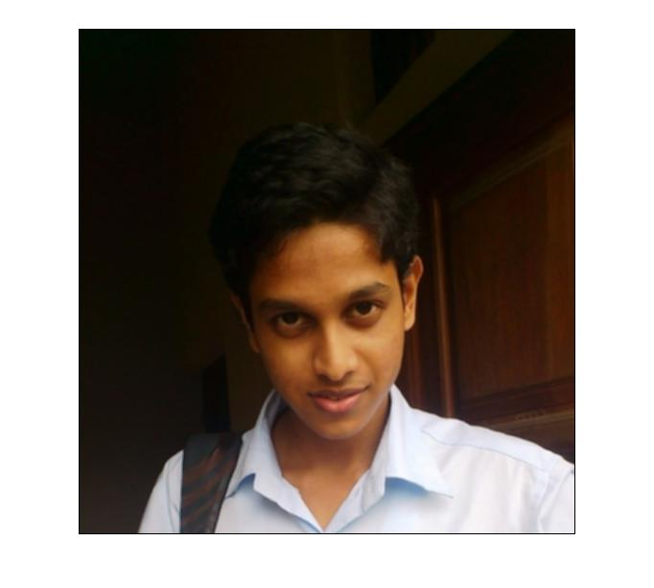

**b. Gaussian Blur**

Kernel =

0 0 0 5 0 0 0

0 5 18 32 18 5 0

0 18 64 100 64 18 0

5 32 100 100 100 32 5

0 18 64 100 64 18 0

0 5 18 32 18 5 0

0 0 0 5 0 0 0

>> tot = sum(Kernel (:))

tot =

1068

>> Kernel = Kernel / tot

Kernel =

0 0 0 0.0047 0 0 0

0 0.0047 0.0169 0.0300 0.0169 0.0047 0

0 0.0169 0.0599 0.0936 0.0599 0.0169 0

0.0047 0.0300 0.0936 0.0936 0.0936 0.0300 0.0047

0 0.0169 0.0599 0.0936 0.0599 0.0169 0

0 0.0047 0.0169 0.0300 0.0169 0.0047 0

0 0 0 0.0047 0 0 0

**Implementation using my function**

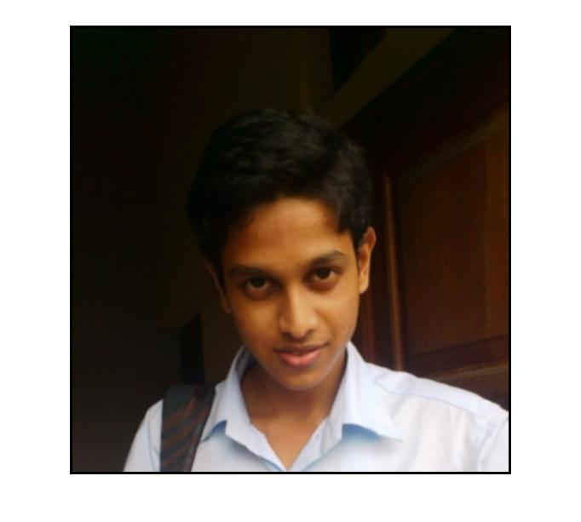

**Using conv2 function**

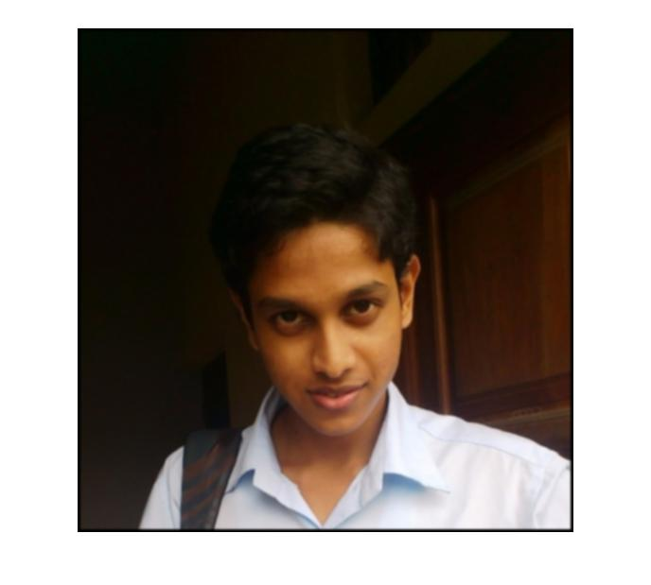

**2. Edge detection**

Kernel =

-1 -1 -1

-1 8 -1

-1 -1 -1

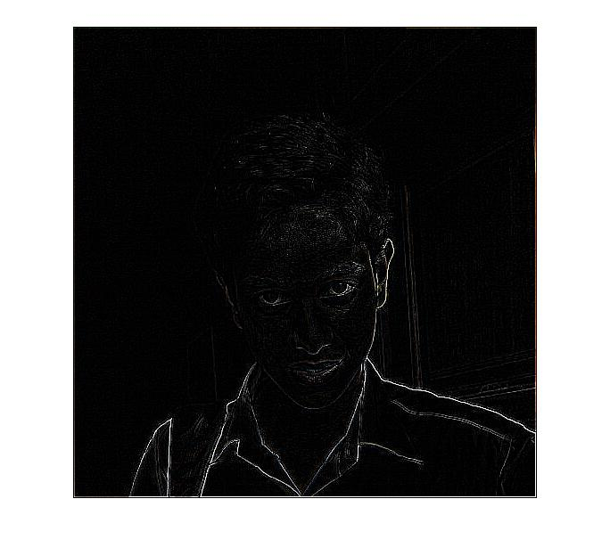

**Edge detection with Sobel Edge Operator**

**a. Horizontal**

Kernel =

-1 -2 -1

0 0 0

1 2 1

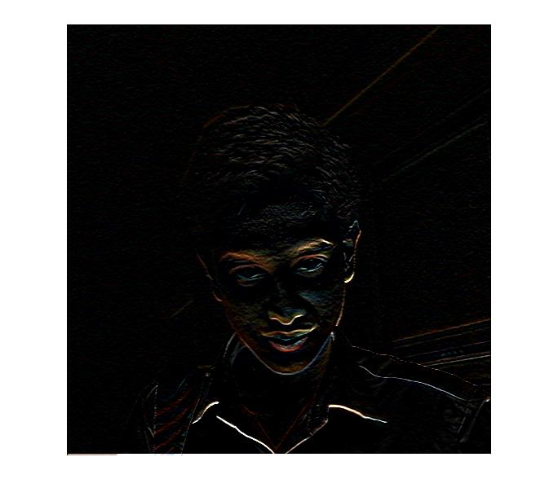

**b. Vertical**

Kernel =

-1 0 1

-2 0 2

-1 0 1

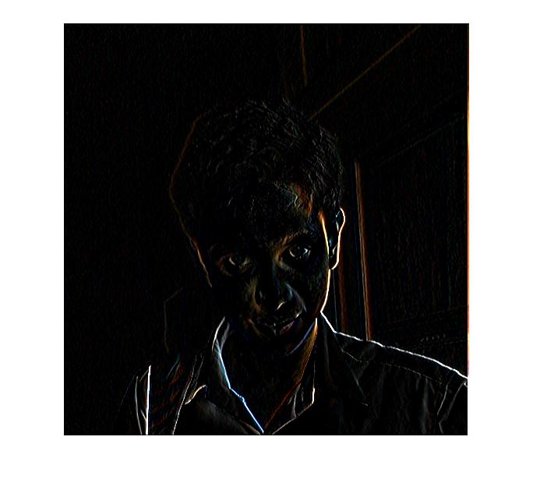

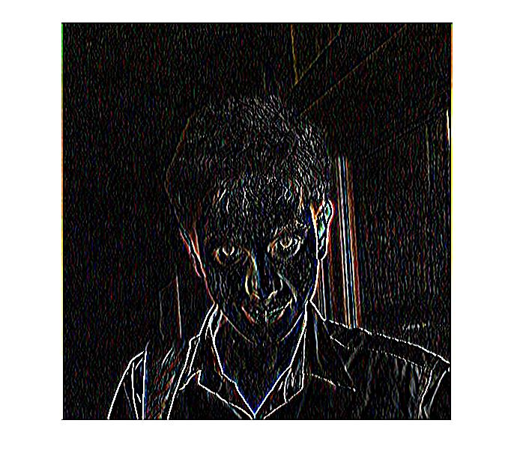**c. With both convolutions applied**

**3. Sharpening**

Kernel =

0 -1 0

-1 5 -1

0 -1 0

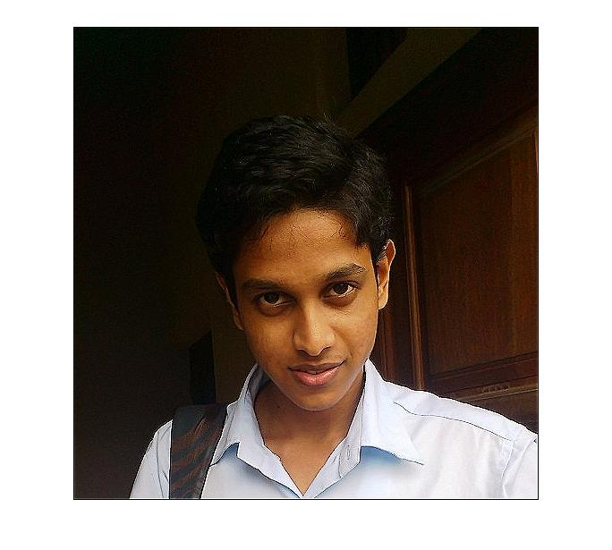

**Other Convolutions**

**1. Line detection**

**a. Horizontal Lines**

Kernel =

-1 -1 -1

2 2 2

-1 -1 -1

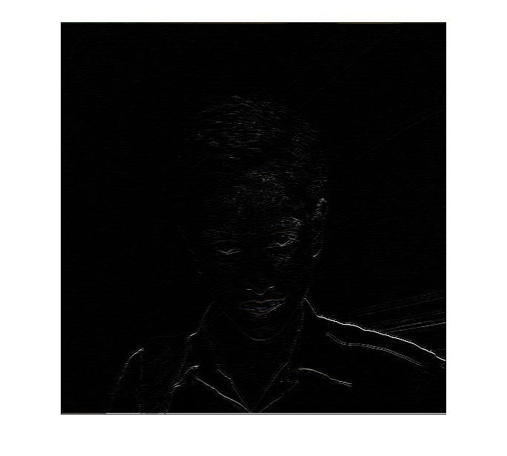

**b. Vertical lines**

Kernel =

-1 2 -1

-1 2 -1

-1 2 -1

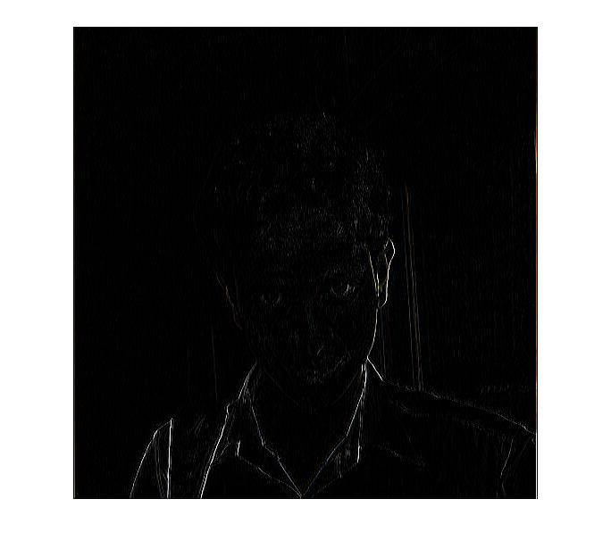

**c. 450 lines**

Kernel =

-1 -1 2

-1 2 -1

2 -1 -1

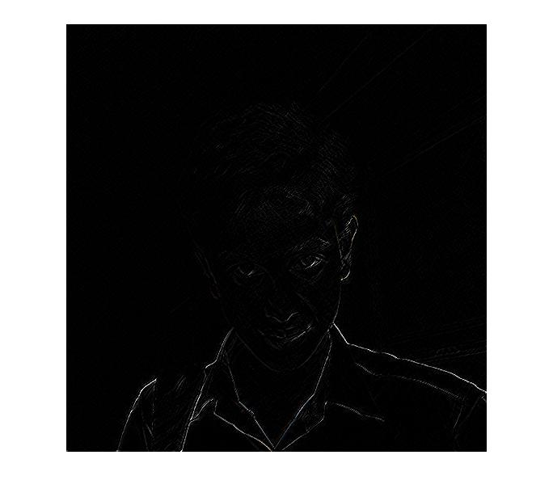

**d. 1350 lines**

Kernel =

2 -1 -1

-1 2 -1

-1 -1 2

